***Scarf Protects Ears In Winter Against Cold***

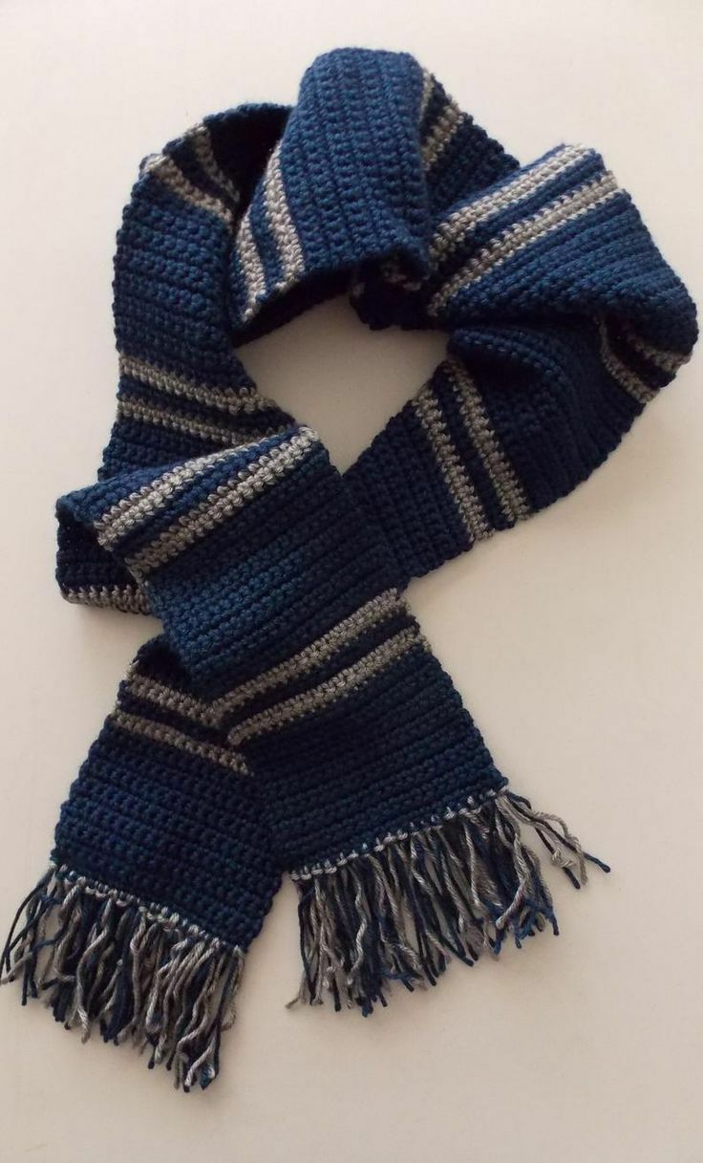

*Style: Classical Ethnic Length (cm): Bandana Product code: Cotton Bandana Width (cm): 22cm Weaving method: Warp knitting Texture: Monochrome Foreign Trade: Yes Function: warm Processing method: woven flower*